What Even Is a Macchiato?
By JesseMae Rayer

The higher content of espresso in a macchiato brings out the rich taste of a cafe’s coffee blend. Coming from a surprisingly utilitarian Italian origin, this drink is a great way to get your daily dose of caffeine.

The Basics
A macchiato sounds fancy, and often it can be, but it all boils down to just espresso and steamed milk. What’s really important is the ratio. The steamed milk is usually added in a 1:2 ratio, poured as a thin layer on top.
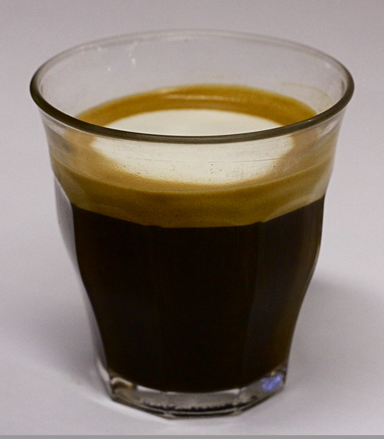
Steamed milk is slightly different from frothed milk. When steaming, air is pulled from the drink, creating a creamier, silkier texture than a frothed version.

And it’s not just a mug filled up with pure espresso (thankfully, for the sake of my mother’s caffeine addiction). Macchiatos are served much smaller than a frappuccino– usually only 1 and a quarter ounces.

Mostly served hot, they do come in an iced variety. Just swap out the steamed milk for a chilled varietal, and it might be more bearable on a summer afternoon.

History
Like some of the best things (ie pasta), the macchiato is Italian. It was created in the 1980’s as a way to differentiate between plain espresso, or espresso with milk. And there’s the name- coming from ‘stained’, they ‘stained’ the top of the drink with the steamed milk so they could tell the difference.

The macchiato was Americanized fast. In the 80s and 90s, the United States began to make their mark on our view of the drink. Often including more milk, flavorings, and growing in size, they began to resemble other drinks you might know better, like a frappe.

What’s the Difference?
A macchiato is used often as a way of adding sugar to espresso without ‘tainting’ the drink. Stronger than drip coffee, it’s a great way to get your caffeine hit in the morning, and allows you to get a more intense coffee flavor.
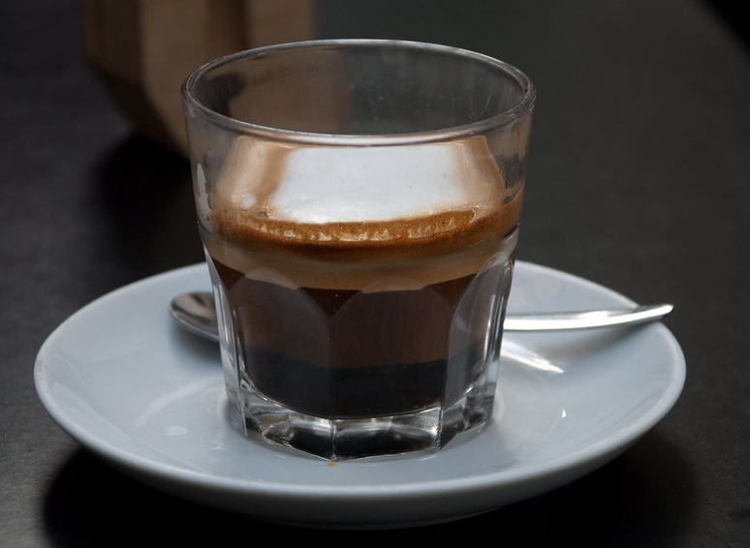
Macchiatos also only contain a splash of milk, and therefore tend to have lower calories, fat, and protein contents than other drinks.

A cappuccino, on the other hand, has a 1:1:1 of espresso, steamed milk, and milk foam. A latte has even more steamed milk, with around two thirds of the drink consisting of it. All are great ways to enjoy a cup of joe.

It’s Just Good Sense
At Good Sense, you can experience the best of coffee with the highest quality beans. This gets meaningful when you’re sipping a macchiato, and we make sure you get the best tasting drink in town.

Try our macchiato today!

